|  |  |  |  |
| --- | --- | --- | --- |
|  | | **INVENTION DISCLOSURE** | Legal Department Docket No. |
| I / We  (First name and surname of inventor(s) – further details and signature(s) on last page)  Nobuyoshi Hiramatsu, Harald Etschmaier | | | Date Invention was Conceived (if known): |
| disclose here this invention specified in full on the following pages with the title:  **Depolarized light scattering for smoke detection** | | | |
| **I.** | TO  ams AG – Legal Department  Tobelbader Straße 30, 8141 Premstätten, Austria | | Received by Legal (date): |
| **­** | **TECHNICAL BOARD DECISION**  INVENTION DISCLOSURE RANKING:  A: First Filing at the European Patent Office (EP)  B: First Filing in another country (please specify):  C: DO NOT FILE  For Rank C please check the following items:  does not exceed prior art  is not within ams business interest and can be released to the inventor(s) without reservations  other reasons (please comment): | | Responsible  TB Member: |
| **III.** | **LEGAL DEPARTMENT INPUTS**  FOREIGN FILING LICENSE  Regarding the requirement for a Foreign Filing License:  Was the invention made at least partially in the US or is at least one of the inventors a US citizen?  yes  no  Is at least one of the inventors a resident of India?  yes  no  Further remarks:  **LEGAL DEPARTMENT INPUTS CONTINUED**  APPLICANT  ams AG, AT  ams International AG, CH  Other:  The above applicant has acquired the right to the invention  as employer *(please specify in case this is not applicable for all inventors)*  by an agreement with *(name of inventor)*:  dated: | |  |
| **IV.** | **The following pages are to be completed by the inventors.**  **Please answer the following questions as completely as possible, adding on additional attachments or sheets if necessary.** | |  |

**(Please submit your disclosure in ENGLISH only)**

1. **Field of the Invention – What problem is being solved by this Invention?**

High reliability is required for a smoke detecting system in the application of fire alarming. The scattering light system for smoke detection has been conventionally used, due to its advantages of long operating life, less signal drift, and fast response as well as low commercial cost. However, the conventional system is not suitable for use in certain circumstances such as industrial plants, kitchens, and smoking area where the fire alarming is intrinsically necessary, as there exist other aerosols including water vapours, cigarette smoke, dusts, and fumes produced by hot grease that can be causes of false alarming in the system degrading the reliability. Besides, detections of a mixture of smokes that originate from various combustible materials and unknown smokes are less reliable for the conventional system, since it hardly identifies the smokes from the other aerosols by their scattering properties with individual reference data stored in the memory of the system, and may produce erroneous results.

The smoke detecting system is typically contained in a smoke chamber for shielding ambient light, and a portion of the smoke chamber protrudes outwards so as to facilitate smoke inflow into the smoke chamber. However, a desirable characteristic of smoke inflow can be harmed and the smoke sensing may delay, due to the smoke chamber and elements arranged around the smoke chamber such as a cover, a smoke inlet, and a labyrinth eliminating the influence of ambient light. Such a smoke chamber enlarges the size of the system limiting the miniaturization of the system. Moreover, dusts or the like adhere or dew forms inside the smoke chamber while the smoke sensor is in an installed state, and signal to noise ratio may be deteriorated or false alarm may occur due to light reflected inside the smoke chamber.

The disclosed invention describes an integrated smoke detection system with scattering light, which is sensitive to detect smoke particles while reducing the influence of other aerosols and the stray light, by measuring the depolarized scattering light in robust optical configuration that can be manufactured within common sensor packaging techniques. A possibility to combine this invention with a proximity sensor or time of flight sensor was discussed. There are potential needs for integrated smoke detecting systems in portable and personal use as well as in ubiquitously distributed alarming systems that enable us early and reliable fire detection with low cost, small size, and optimized energy consumption which significantly improves its feasibility.

1. **Prior Art – How was this problem solved before? (Known Solutions (References of patents or papers & short description) )**

[1] Photoelectric smoke-sensitive fire detecting device based on depolarization rate (CN200963473Y, 31 Oct 2006)

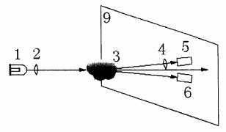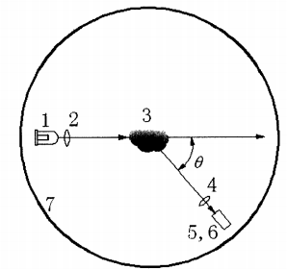Variance of polarization of light scatted by smoke (depolarization rate) is measured for enhancing the recognition of smoke particle from vapor and the response sensitivity, while reducing the false alarm rate. A light source with a polarizer taking the polarization axis parallel to the scattering base plane emits linearly polarized light, and two detectors are placed close to and symmetrical to the scattering base plane with and without a polarizer which has a polarization axis vertical to the scattering plane. The scattering angles are arranged 30° ~100° in this invention, where which is defined as the angle between the transmitted light and the scattered light injecting into the light receiver.

This invention requires spacious and complex optical configuration due to the doubled light receivers and polarizers, therefore, is not suitable for miniaturization.

<https://patents.google.com/patent/CN200963473Y/en?q=photoelectric&q=smoke&q=sensitive&q=fire&q=detecting&q=device&q=based&q=depolarization&q=rate>

[2] FIRE ALARM (US 6,788,197 B1, Sep. 7, 2004)

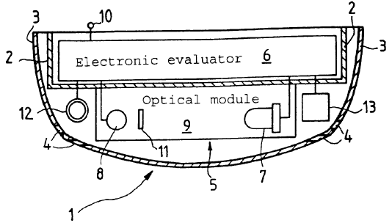Scattering light is collected in two orthogonal polarization planes at a certain angle for improving the smoke sensing characteristics. A LED emits non-polarized light, and an electrically adjustable polarization filter consists of crystal liquid which can rotate its polarization plane by 90°, is arranged in front of a detector that collects the scattered light from smoke at a certain angle.

This invention consumes costs, spaces, and electric energy for the adjustable polarizer and its electrical circuits, reducing the feasibility of the smoke detecting system.

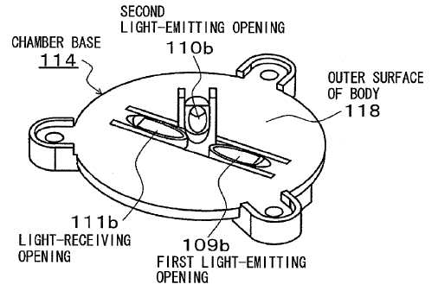[3] LIGHT SCATTERING TYPE SMOKE DETECTOR (US 7,746,239 B2, Jun. 29, 2010)

Without smoke chamber, both forward scattering and back-scattering light are collected for better characterization of the light scattering properties, for some embodiments in this invention. 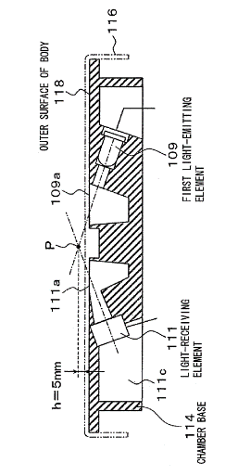One embodiment in this invention (fourth embodiment) contains two light sources with polarization filters for each emitting light at different angles with different polarization state, and a light receiving element.

This embodiment needs two light sources thus increases the cost, energy consumption of the system, and size. In addition, the cross sensing problem against water droplets harms the reliability.

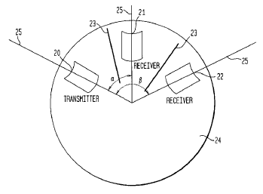[4] SCATTERED LIGHT FIRE DETECTOR (US 6,218,950 B1, Apr. 17, 2001)

Smoke particles are characterized by collecting light from scattering volume at two different angles in both forward and backward scattering regimes, for improving the reliability by taking darkness of the smoke into consideration.

However, high angular resolution is necessary for this invention resulting in small scattering volume of smoke and long optical path. Besides, for the aerosols including non-spherical particles such as smoke, the analytical angle-dependent scattering theories are no longer available and it is difficult to distinguish smoke from other aerosols including the water droplet.

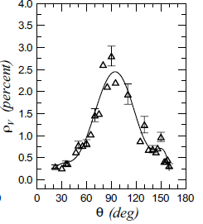[5] Experiments on depolarized optical scattering to sense in situ the onset of early agglomeration between nano-size soot particles (Stefano di Stasio, *J. Quant. Spectrosc. Radiat. Transfer,* 2002)

Depolarized scattering are experimentally evaluated in this paper. Vertical depolarization ratio $ρ_{v}$, the variance of the polarization in the scattering process as injecting vertically polarized light with respect to the scattering plane, takes the maximum in the scattering angle 80~120°, where the smoke is released in the air-ethylene combustion process by the Bunsen burner. The size and the fractal dimension of the smoke particle are estimated to be 40nm and 1.7.

1. **How does the invention advance over the Prior Art?**

**What’s new? What distinguishes it from the prior art?**

-Emitting linearly polarized light via a prism coat enhancing the polarization.

-Detecting depolarized scattered light while shielding the co-polarized scattering light with a polarizer attached in front of the light sensor.

-Possibility to combine with a proximity or time of flight sensor without smoke chamber.

-A light source and a light receiver are placed on a same plane that significantly reduces the height.

**Why is it better?**

-Short mean optical path and relatively large scattering volume enhances the sensitivity

As the scattering properties depending on the angle does not play a principal role for this invention, an angular divergence is acceptable for both emitter and receiver allowing the short optical path and relatively large scattering volume where the system is sensitive to smoke.

-Deducing the size and cost of the system

The overall height and total packaging cost can be significantly reduced, since a coating prism covering the light source manipulates the optical path and the polarization while protecting electric contacts, and the light source and the light receiver are placed on a plane.

-Easy manufacturing and testing

Due to the simple and robust setup of the detection system without smoke chamber, any complex optical element that needs a special process is no longer required and in situ the system can be tested during the manufacturing process.

-High reliability, and stability for cross-sensing problem against water droplet.

Influence of stray light can be reduced by introduction of the polarizer.

The scattered light that originated from water droplets cannot be depolarized in principle.

-Possibility to combine with a proximity or time of flight sensor without smoke chamber

Because of the similarly to a proximity sensor (and Time-of-Flight sensor) in the optical configuration, their functionalities can be integrated on a same chip. Moreover, by locking the pulse input mode of VCSEL with the signal output, we could considerably improve the signal noise ratio.

1. **Brief Description of Drawings**

-Drawing.1 shows a sectional view of an embodiment.

-Drawing.2 shows a trimetric projection of an embodiment.

-Drawing.3 shows fundamental properties of the polarization dependant light scattering for spherical and non-spherical particles. The polarization state would not be altered in the scattering process for a spherical particle due to its central symmetry of the shape, whereas the polarization would be depolarized for non-spherical particles including smoke particles.

-Drawing.4 is a simplified schematic of the system. Linearly polarized light is scattered and depolarized by the smoke, and the depolarized scattering light is detected while the co-polarized scattering light is shielded by a polarizer in front of the detector.

1. **Detailed Description of Preferred Embodiments**

**(Examples of the invention)**

Embodiments contain a base die, a light source, a light receiver, a polarizer, a colour filter, a fence, and a prism coating of the light source. The base die facilitates electrically connecting a light source and a light receiver with outer electric circuits for power supply and signal processing, and works as a mechanical frame of the optical setup. The light source is attached on the base die to emit loosely divergent beam perpendicularly to the base, and we preferably supposed a VCSEL (Vertical-Cavity Surface Emitting Laser) in infrared range for the light source. The light receiver is attached on the base die to detect scattering light, and we preferably suppose a sensitive photodiode such as an avalanche photodiode for the light receiver. The polarizer is attached on the light receiver so as to shield the co-polarized scattering light. The colour filter is placed on the polarizer for reducing influence of ambient light. The fence is opaque or reflective in the wavelength range of the light source, attached on the base so as to encircle the light receiver for manipulating optical path and reducing the influence of stray light. The prism covering on the light source is composed of an optical dielectric such as a glass and organics, and we assume the refractive index of the dielectric as 1.5 hereafter in this embodiment, though other dielectric with different indexes are also applicable for the prism coat in this invention. The prism coating has two sloping walls, or dielectric-air interfaces facing one another: a wall that overhangs the light source with sloping angle 67° to the base (interface 1) behaves as a mirror for the vertical emitted light as the incident angle is bigger than the critical angle of the total reflection and behaves as a transmitter for normal incident light, and another wall with sloping angle 79.7° to the base (interface 2) behaves as a partial mirror for the s-polarized light (s-polarized: its electric field oscillates perpendicularly to the plane of incidence) while perfectly transmitting the p-polarized light (p-polarized: its electric field oscillates parallel to the plane of incidence) at where the incident angle equals the Brewster angle.

The Brewster angle $θ_{B}$, which is an angle of incidence at which the p-polarized light is perfectly transmitted through a dielectric surface with no reflection, is 33.7° for a dielectric-air interface assuming the refractive index of the dielectric to be 1.5, where the Brewster's angle is given $θ_{B}=Arctan(1/n)$ according to the Fresnel equations. The critical angle $θ_{c}$ of total reflection is similarly calculated as 41.8° for any polarization state on the dielectric-air interface as given $θ_{c}=Arcsin(1/n)$.

The beam emitted from the light source, propagates inside the prism to be internally reflected by the interface 1, and reaches the interface 2 so that the incident light satisfies the Brewster condition for reflecting light with desired polarization (s-polarized) while transmitting the rest. Then the reflected light on the interface 2 propagates to be normal incidence on the interface 1 to transmit outwards injecting to the light scattering regime. As there exist smoke particles in light scattering regime, a portion of the incident light changes its propagating direction and its polarization from linear polarization state which is vertical to the scattering plane to cross-polarization state (partial polarization). The scattered light with co-polarized component that reaches the light receiving unit is filtered by a film polarizer with a polarization axis parallel to the scattering plane attached on the light receiver, while the scattering light with depolarized component transmits the polarizer and reaches into the light receiver. Mean scattering angle is roughly optimized to be 100°~120° for enhancing the signal-noise ratio, since the depolarization ratio of scattering light should be a maximum in the scattering angle 80°~120° according to the preceding study [5] and the intensity of scattering light increases in the forward scattering regime. As the light source emits partially polarized light, its polarization axis should be arranged so as to maximize the intensity of the desired light incident into the smoke sensitive regime.

Embodiments may contain a smoke chamber for improving the signal-noise ratio, so that ambient light cannot be injected into the photosensitive regime while maintaining the path of smoke inflow. Embodiments can combine its functionality with a proximity sensor or a time of flight sensor without the smoke chamber, as optimizing the configuration of the prism coating to emit the polarized light upwards. The proximity of objects and the distance to the objects as well as the existence of the smoke are estimated by the calculation of intensity and delay time of signal in light receiver. In any case, the influence of stray light is reduced in this invention, because the scattering light will be the

1. **Proposed Claims** (optional)

- Integrated smoke detector which has a prism generating beam with desired polarization.

- Smoke detecting system that combined with proximity sensor without smoke chamber

1. **Drawings**

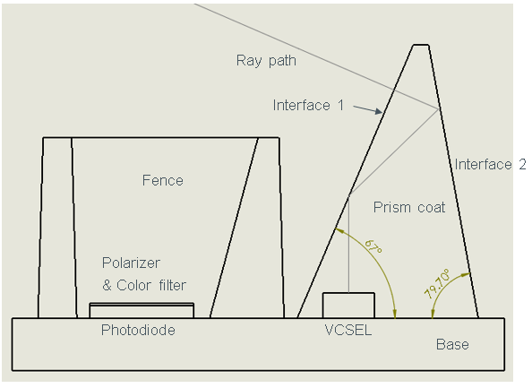

**Drawing. 1**

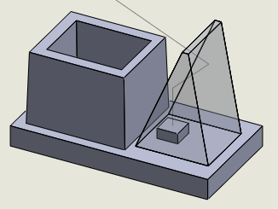

**Drawing. 2**

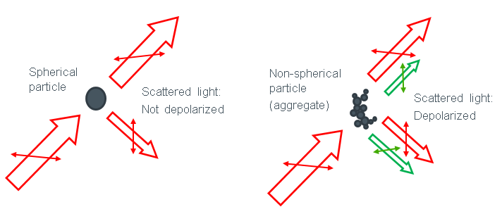

**Drawing. 3**

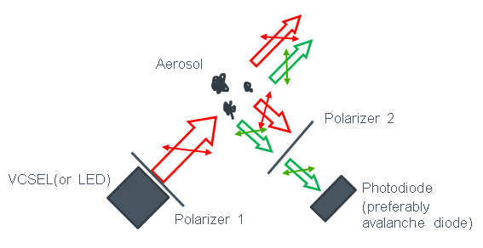

**Drawing. 4**

|  |  |  |
| --- | --- | --- |
| **V.** | **SUPPLEMENTARY INFORMATION TO BE COMPLETED BY INVENTOR(S)**  Which business units are potentially interested in the invention?  **Mobile ware market, Safety agency** |  |
| Which product(s) is the invention applicable to?  **Mobile phone, smart watch, ubiquitous fire alarming system** |
| Has the invention been tested already?  no  yes, results: |
| Has the invention (samples, presentation) been disclosed to third parties or is such a disclosure intended?  no  yes, (estimated) when:  to:  Has the invention been published or is publication intended?  no  yes, (estimated) on:  in book/journal:  Further remarks: |

|  |  |  |  |  |  |
| --- | --- | --- | --- | --- | --- |
| **VI.** | **INVENTOR(S) INFORMATION & SIGNATURE** *(enter information for inventors 1 to 4 here. For further inventors, please use an additional sheet)* | | | | |
|  | Inventor 1 | Inventor 2 | Inventor 3 | Inventor 4 |
| First Name: | Nobuyoshi | Harald |  |  |
| Surname: | Hiramatsu | Etschmaier |  |  |
| Private Home Address | | | | |
| Street: | 60-45 Jokoji |  |  |  |
| City: | Namerikawa, Toyama |  |  |  |
| Zip code: | 936-0848 |  |  |  |
| Country: | Japan |  |  |  |
| Citizenship: | Japan |  |  |  |
| Office Contact Information | | | | |
| Phone: |  |  |  |  |
| Fax: |  |  |  |  |
| E-Mail: | japanista.nobuyoshi@gmail.com |  |  |  |
| Badge Nr. |  |  |  |  |
|  | | | | |
| Who is your employer (ams AG, ams International, AMS-TAOS USA Inc., etc.)? | | | | |
|  | ams AG |  |  |  |
| Your location (country): | | | | |
|  | Austria |  |  |  |
| What is the percentage of your contribution to this invention? | | | | |
|  | 50% | 50% |  |  |
|  | | | | |
| To the best of my/our knowledge, each person listed is an inventor and no further persons participated as an inventor to the invention. | | | | |
| Signatures  (typed) | Nobuyoshi Hiramatsu |  |  |  |